Signing on to the B601 : /FOR B601 <enter>

ACTION = NA
RENT STA = Valid Budget Wizard Fleet Owner or rental station number.
<enter>

*****

Car Availability screen : /FOR STDBAVL <enter>

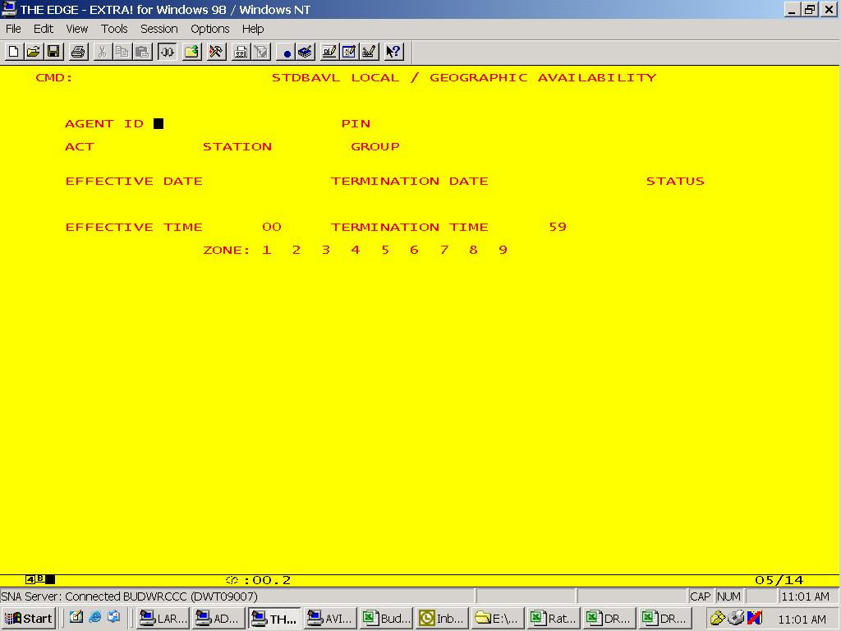

For US Corp locations only, Agent ID and PIN number are required fields. Patty Manning will be the PIN administrator.

I. ACT : valid actions are LOC, GEO, STD and NOS

LOC is used for suspending or opening vehicles for a continuous time period for round trip/Zone 0 rentals.

GEO is used for suspending or opening vehicles for one way zones for whole days.

STD is used for suspending or opening vehicles for a specific time frame on consecutive days (example : cars are suspended 1200-1300 Monday through Fridays).

NOS is used for No Show status a.k.a. Credit Card Guarantee.

II. STATION : valid input is any four digit Budget Wizard rental, district or fleet owner station.

III. GROUP : valid inputs are any of the 16 Budget Wizard car groups.

For US, Canada, Puerto Rico, Australia, New Zealand and Asia/Pacific those 16 car groups are : X, A, Z, B, C, D, E, S, P, G, H, L, K, W, V, F

For EMEA and LAC those 16 car groups are : A, B, C, D, E, F, G, H, I, J, N, P, L, M, O, K

IV. EFFECTIVE and TERMINATION DATE : format is DDMMMYY
To set the Default Status, enter DEF in EFFECTIVE DATE field.

V. STATUS : valid status are

A = Available, used with STD, LOC and GEO
S = Suspend, used with STD, LOC and GEO
Y = Yes, used with NOS
N = No when used with NOS; = Not In Fleet when used with LOC
L = Not In Fleet, used with GEO.
Note : Before a car group can be set to Not In Fleet, a request to delete the vehicle from Budget Wizard must be sent to Budget Change Control first and Change Control will set the car availability status.

VI.
EFFECTIVE TIME __00 : valid values are 00 or 06 through 23

TERMINATION TIME __59 : valid values are 00 or 05 through 23

Note : midnight through 5:59 a.m. constitutes one “time bucket” and is indivisible.

VII. ZONE : 1 2 3 4 5 6 7 8 9
_ _ _ _ _ _ _ _ _

These zones are for One Way availability. Valid values are A, S or L (see section V). Zone 6 should contain all destinations to which cars may not be checked into. For this reason, Zone 6 should always be set to S if the car group is in fleet or L if the car group is not in fleet. Zones 7-9 are reserved for US Corporate stations.

Checking Car Availability

To confirm changes made via STDBAVL, use the B501 or B502 screens. The B501 allows you to view all geo zones and all 16 car groups for a specific time of day and the B502 allows you to view all time buckets for all car groups in zone 0 for a specific date.

Note: if a partial day transaction was processed, it must be verified on the B502 screen, as the B501 only displays availability for the specific time you entered in the DT/TMOUT field.

/FOR B501

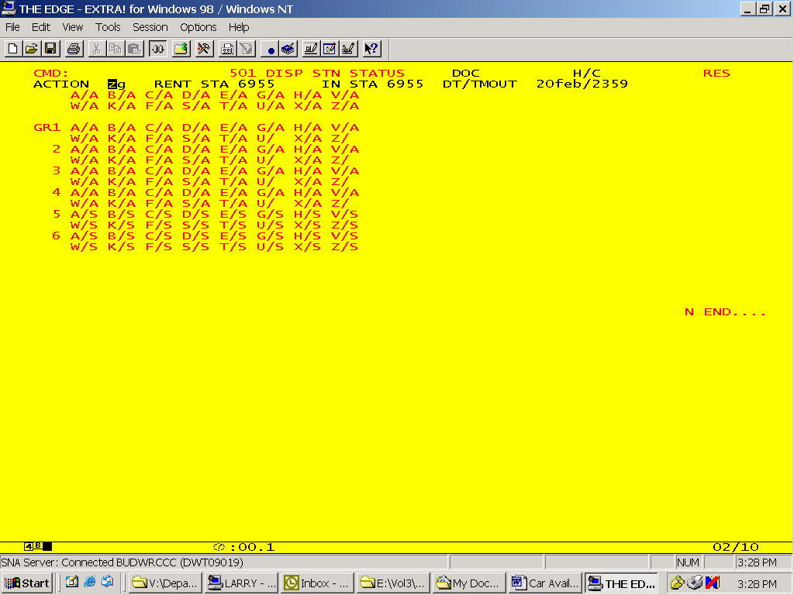

To display all geo zones :
ACTION = ZG
RENT STA = a valid Budget Wizard rental station
IN STA = any station
DT/TMOUT = DDMMM/TTTT where TTTT = is the time of day. Valid times are 0000-2359.

/FOR B502

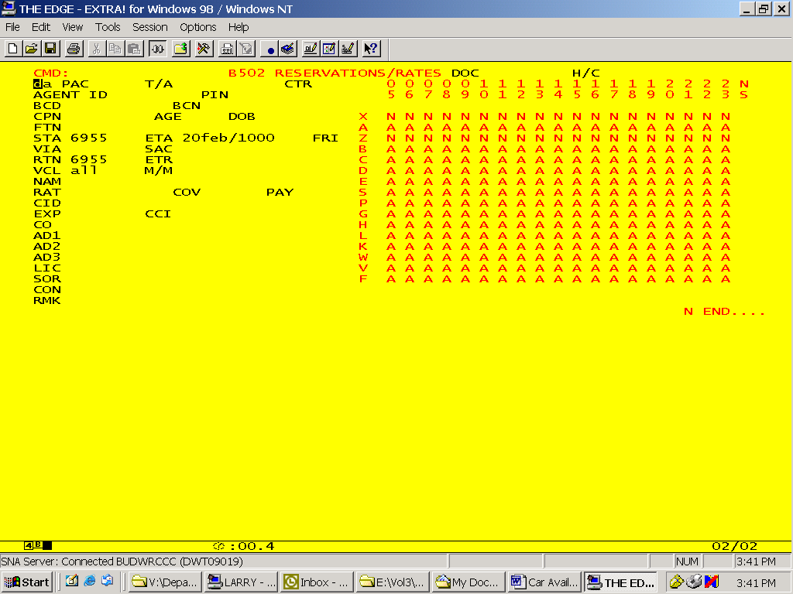

To display all time buskets for a specific date :

___PAC = DA
STA = your rental station,
ETA = DDMMM/TTTT (must be a future Date and Time)
RTN = same station as STA
VCL = all. The display to the right of the screen shows all 16 car groups going down and all valid time buckets across the top (The 05 time bucket represents 0000-0559 and is indivisible).

